About Hacking Club
Hacking Club is a platform to learn cybersecurity, an incredible resource if you don’t know where to start. In addition to vulnerable machines, you have access to classes and challenges to practice your skills and access to an exclusive community to play and challenge yourself.

The best part about Hacking Club is that it is very hands-on. If you are new to hacking, give it a try.

Introduction
This write-up refers to the PROTOBUF machine. If you require support, please open a ticket in the support channel on the Discord server.

Nmap Scan:
As a first step, we need to know which services are running in the background and which ports are open. So, we will use a tool called nmap.

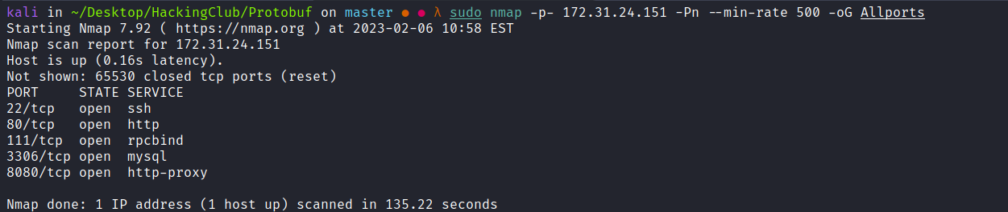
We can start by taking a look at the web application running on port 80.
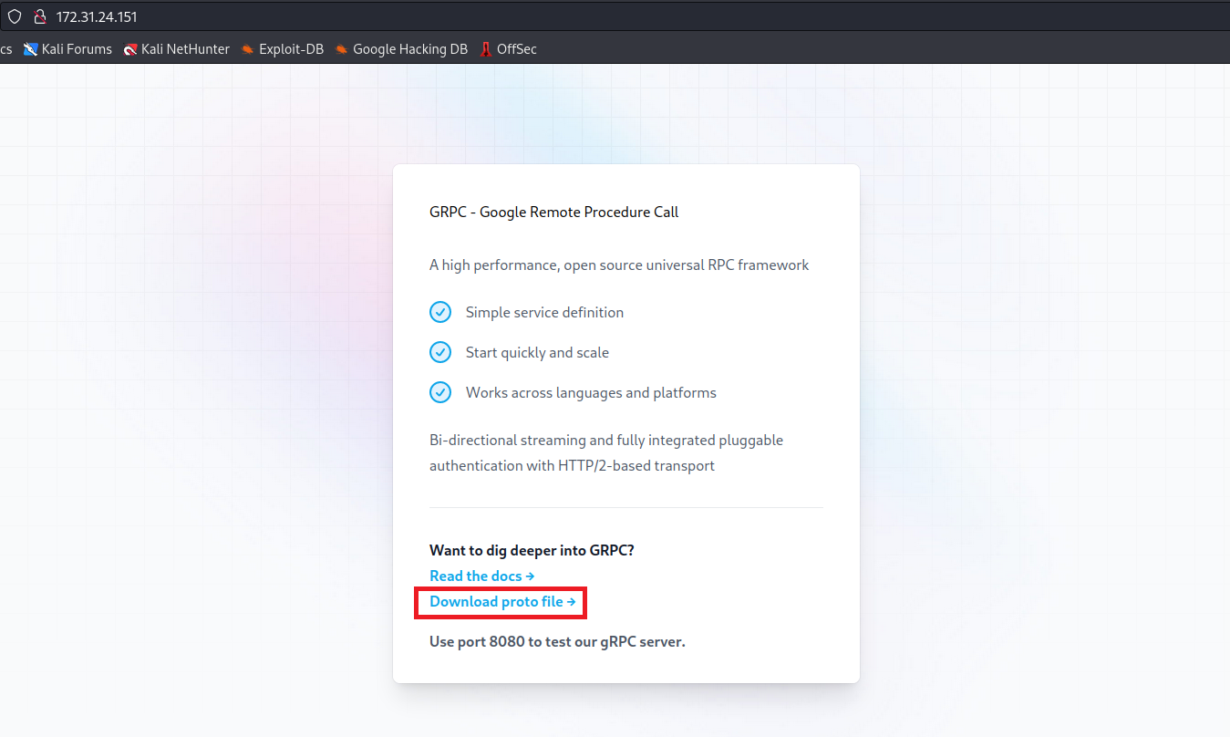
We can download the user.proto file in order to interact with the gRPC service running on port 8080.

What is gRPC?
Before talking about gRPC, we need to understand what RPC is. To avoid mixing concepts, RPC is the definition of a protocol for executing procedures on other computers over a network, and it does not specify how the message is sent from one process to another.
gRPC is a Google framework that implements RPC.
To interact with gRPC, we can use the tool Bloomrpc:
https://github.com/bloomrpc/bloomrpc
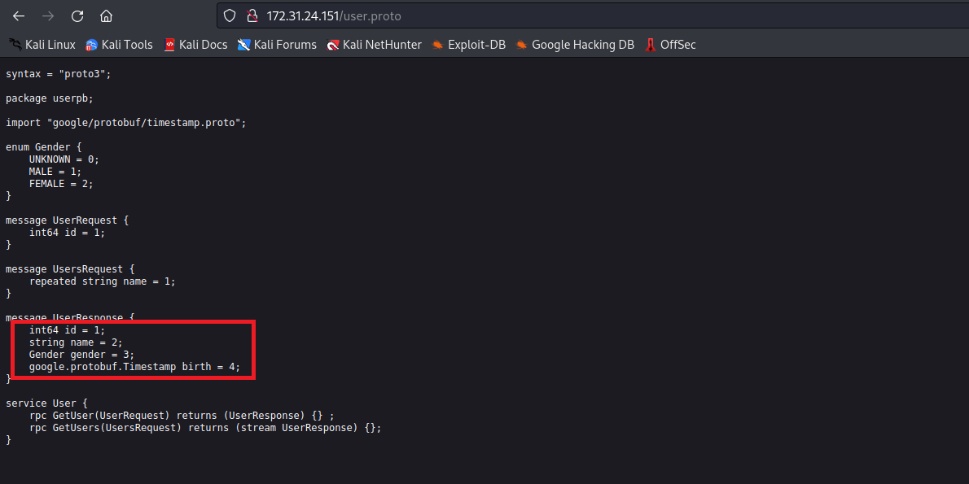
We can use the four parameters shown above, but we will focus only on the name parameter.
After making a request passing the name parameter, we receive an error indicating that the value must be provided in an array.
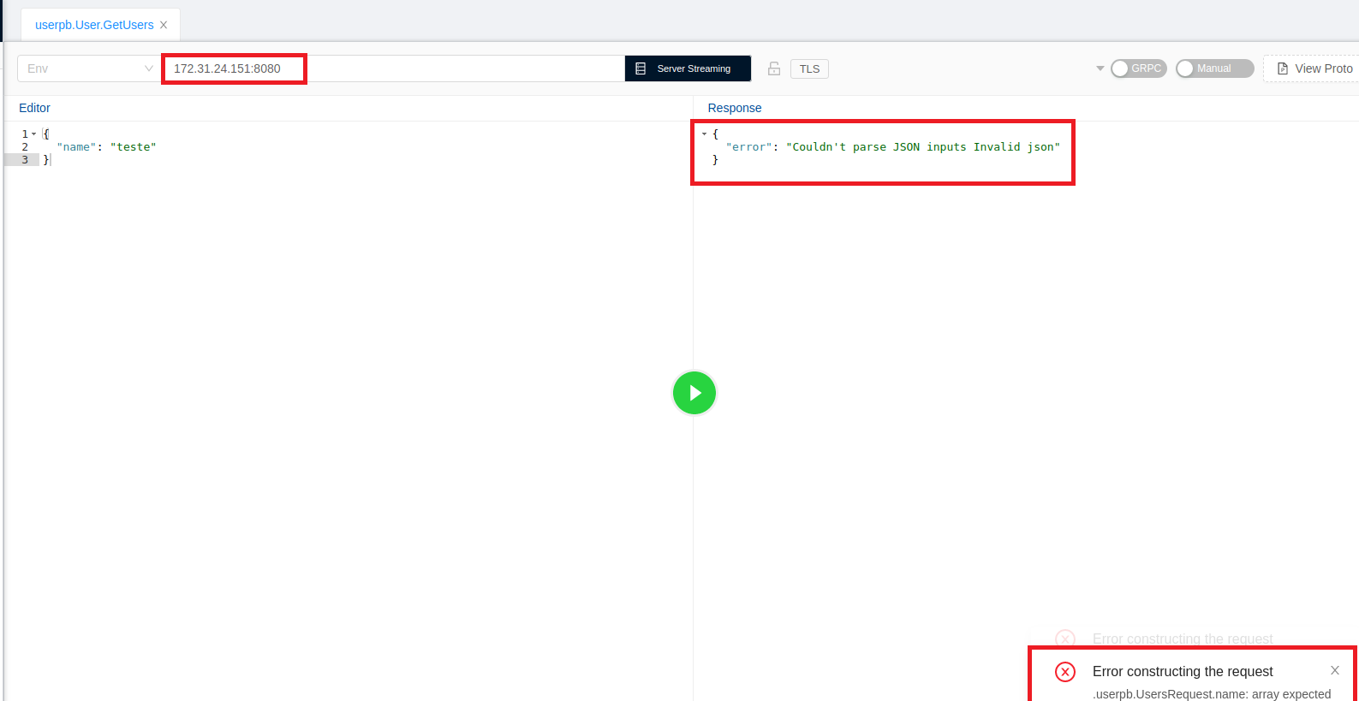

After passing the value of the name parameter and adding single quotes, we receive a SQL syntax error.
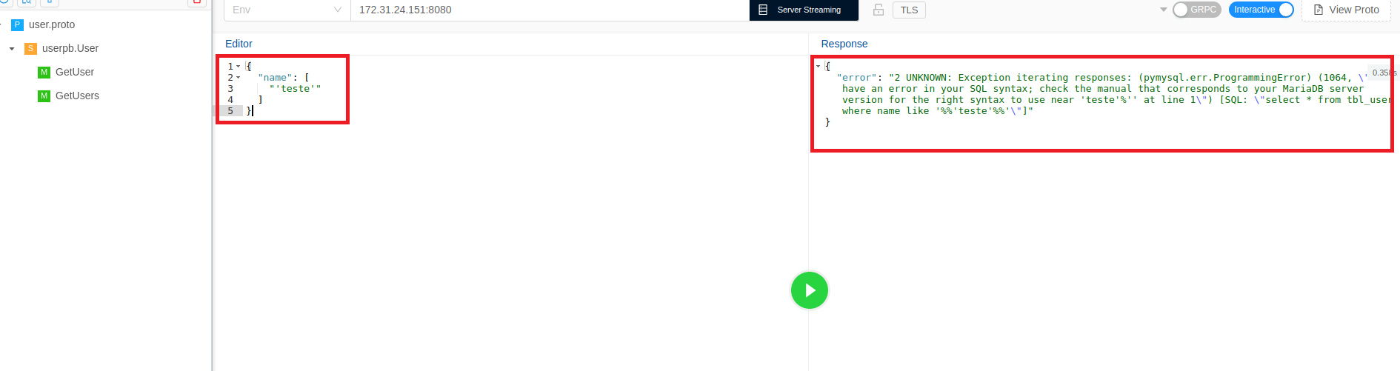

Since we have identified a SQL Injection vulnerability, we can quickly determine the number of columns:
teste' union select 1-- -
teste' union select 1,2-- -
teste' union select 1,2,3-- -
teste' union select 1,2,3,4-- -
After executing the payloads above, we successfully identify that the number of columns is 4.
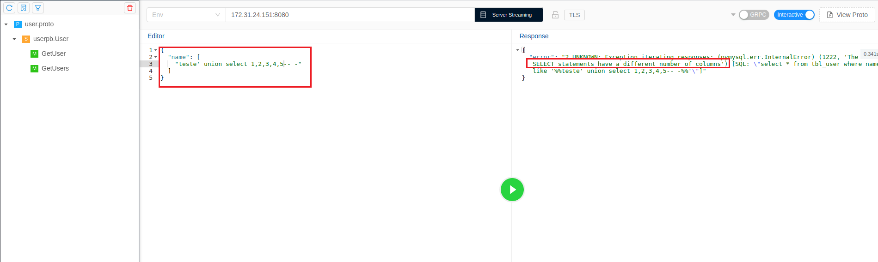
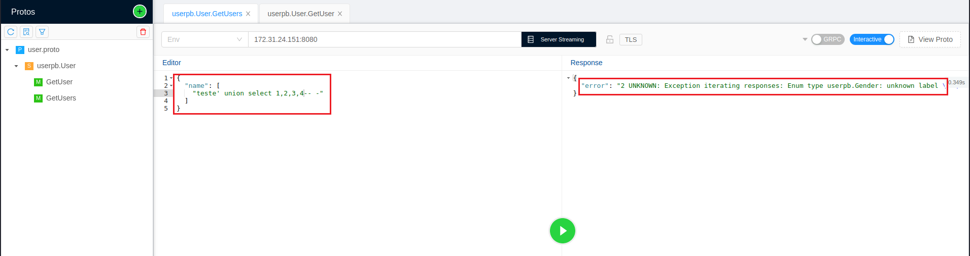
We can read files from the server using the LOAD_FILE() function.
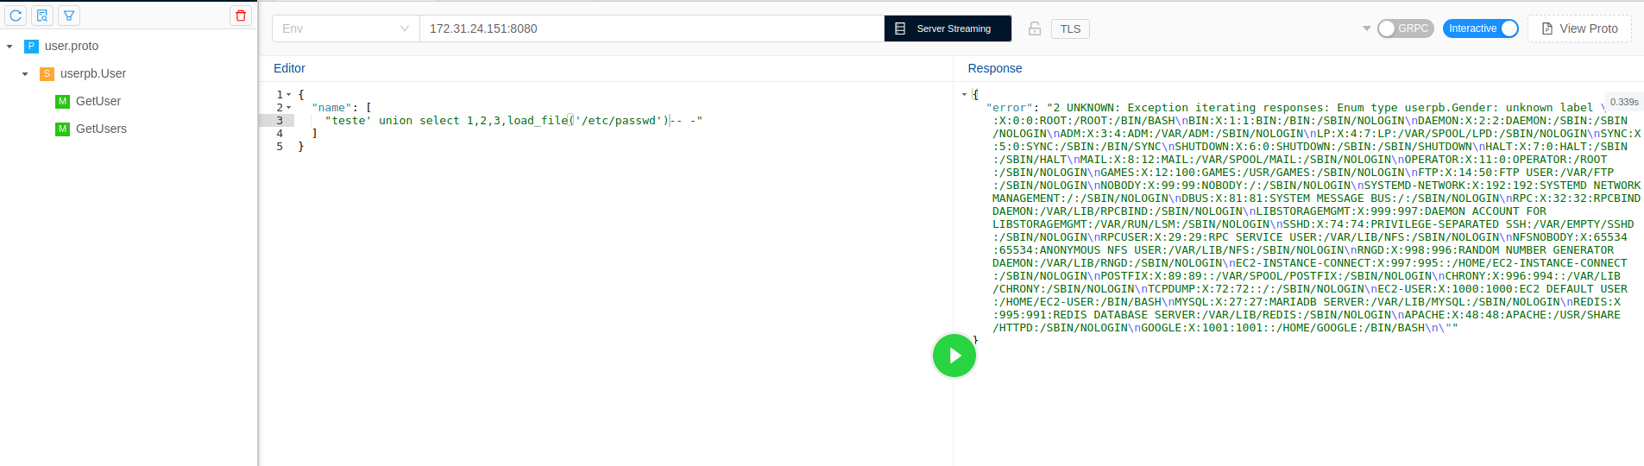
Reading the passwd file, we notice that there is a user named google. We can read the private key id_rsa of this user.
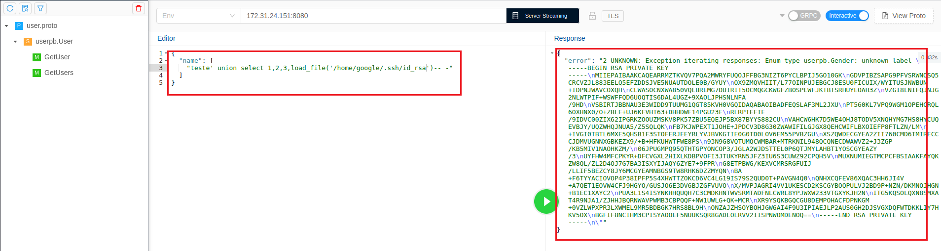
However, we encounter a problem: the file is entirely in uppercase. We can use the hex() function to return the file in hexadecimal format, which preserves the file in its original state.
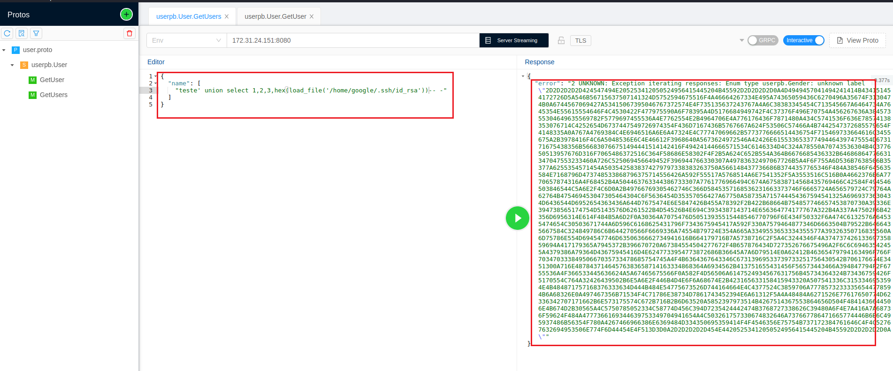
We can use the website CyberChef to decode it:
https://gchq.github.io/CyberChef/
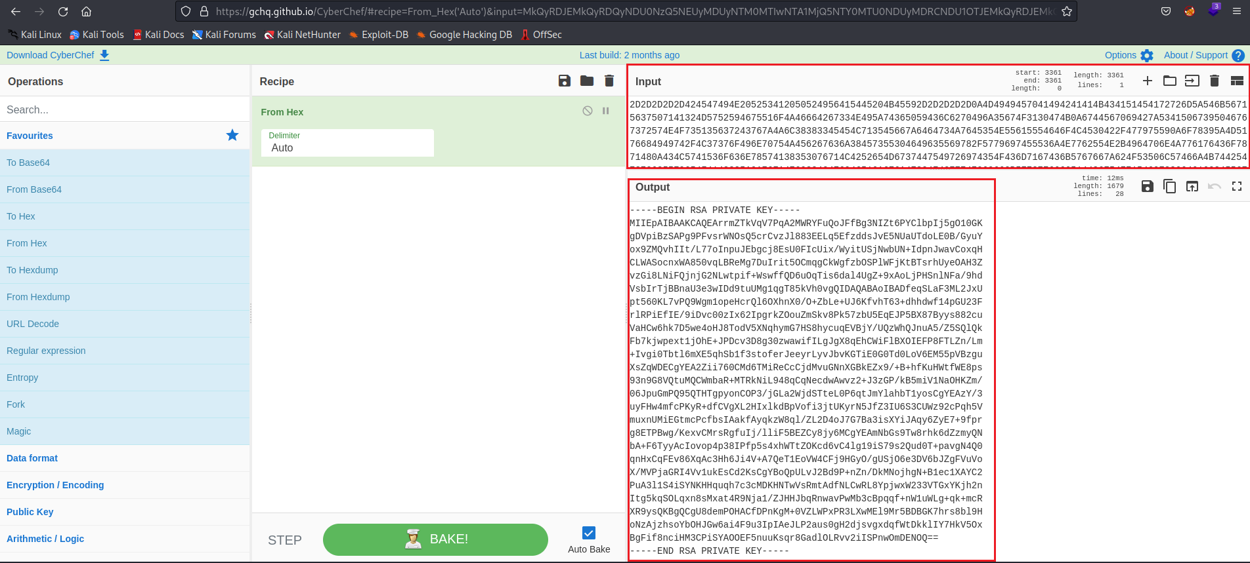
After doing this, we can connect via SSH using the user google and the corresponding private key (id_rsa).
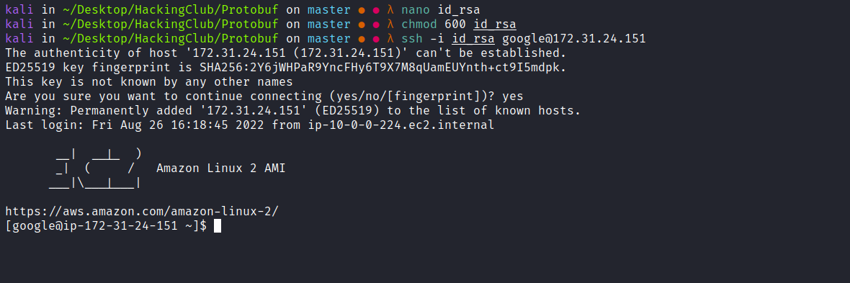
We can retrieve our first flag, which is located in the home directory of the user google.
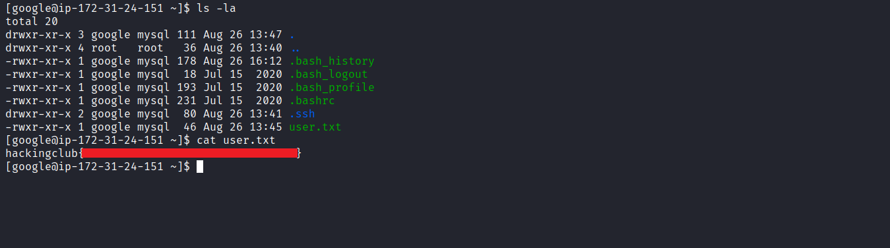
Reading the .bash_history file, we see that the user google executed cat /etc/redis/redis.conf.
We can read this file and filter for the string requirepass to find the Redis password.
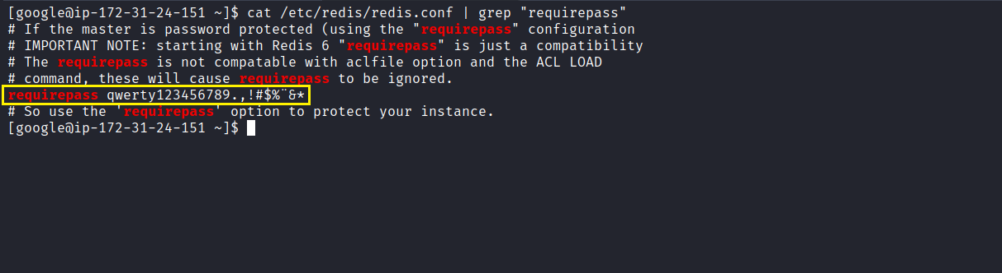
So far, everything indicates that we need to escalate to the redis user. We can load a module into Redis in order to achieve Remote Code Execution (RCE):
https://github.com/n0b0dyCN/RedisModules-ExecuteCommand

6379 - Pentesting Redis
By default, Redis can be accessed without credentials. However, it can be configured to support password-only authentication or username + password. It is possible to set a password in the configuration file using the parameter requirepass, or temporarily until the service restarts by connecting and running:
https://hacktricks.boitatech.com.br/pentesting/6379-pentesting-redis#load-redis-module

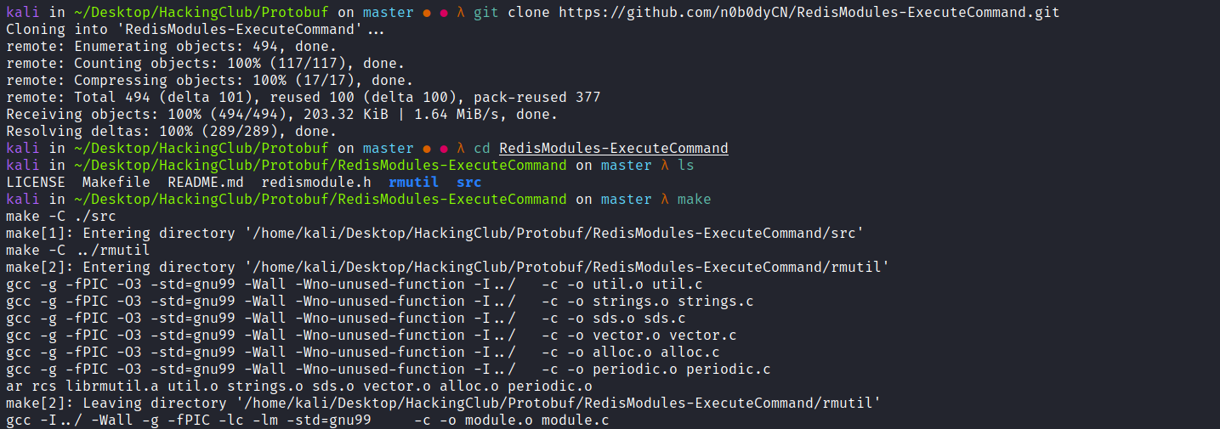

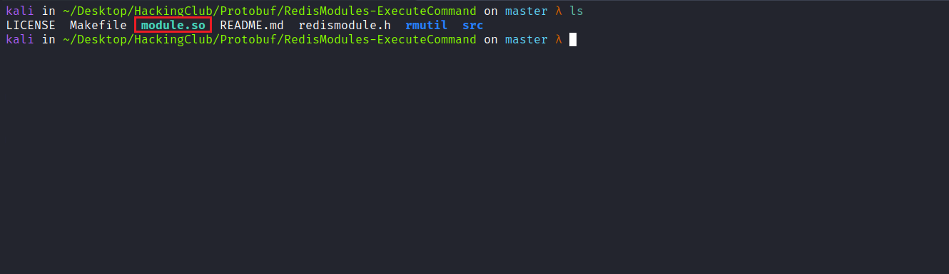
After compiling the module, we send module.so to the server.
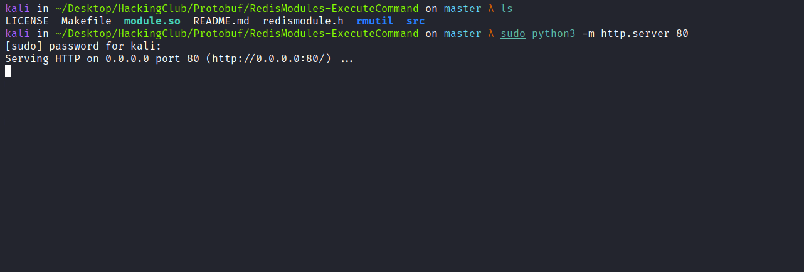
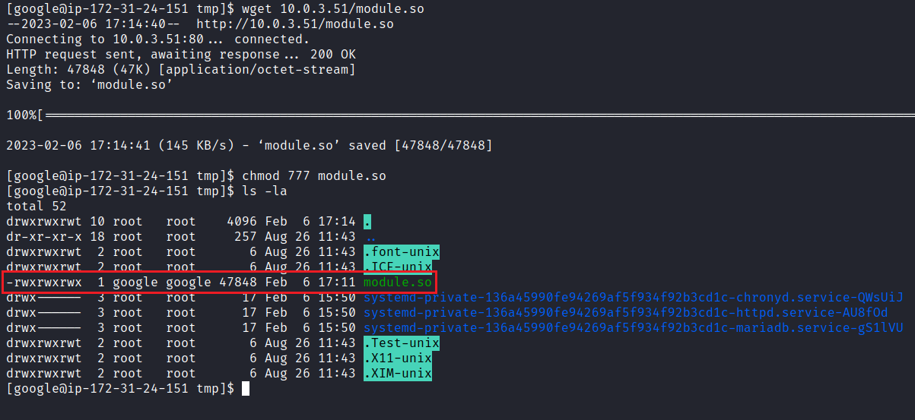
Now we connect to Redis and import the module module.so.
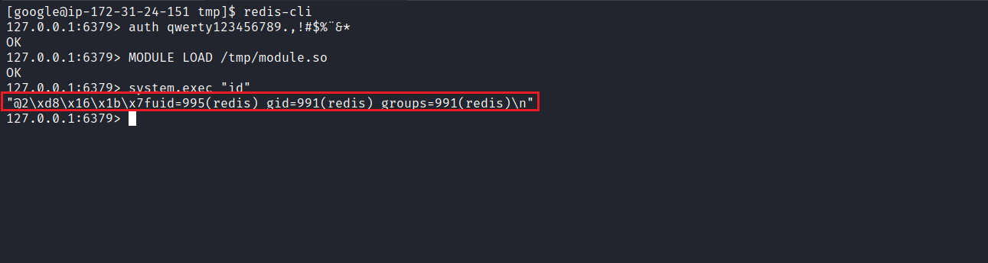
We can obtain a reverse shell.
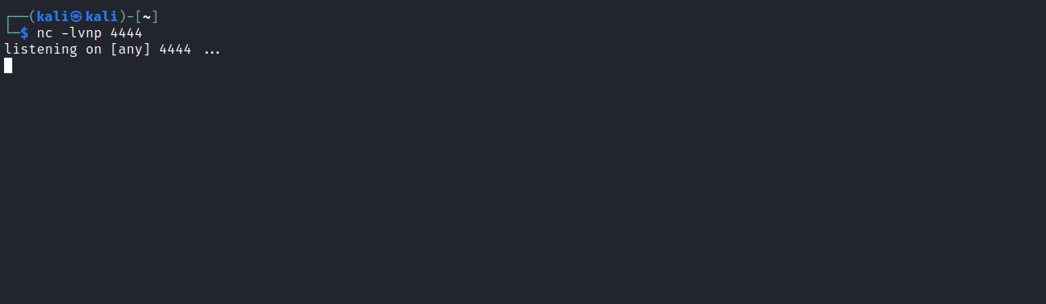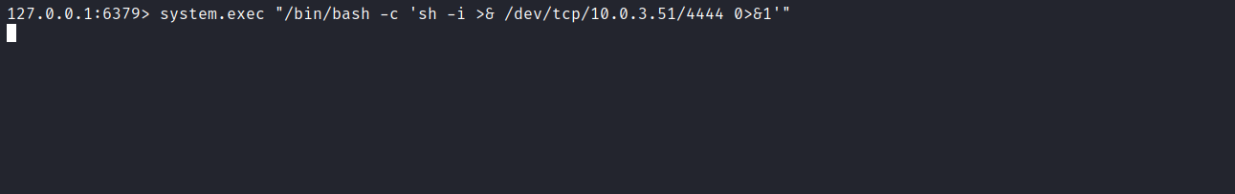
And we now have a shell as the user redis.
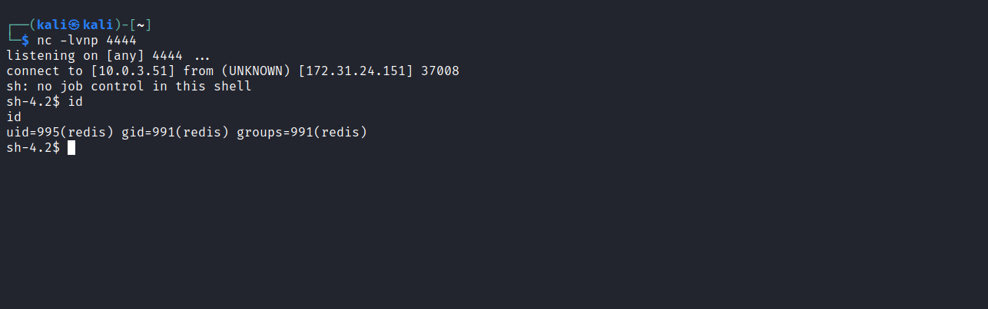
After executing sudo -l we can see that we have the privilege to execute any command with root permissions without providing a password.
Therefore, we can execute sudo bash and retrieve our final flag.
